[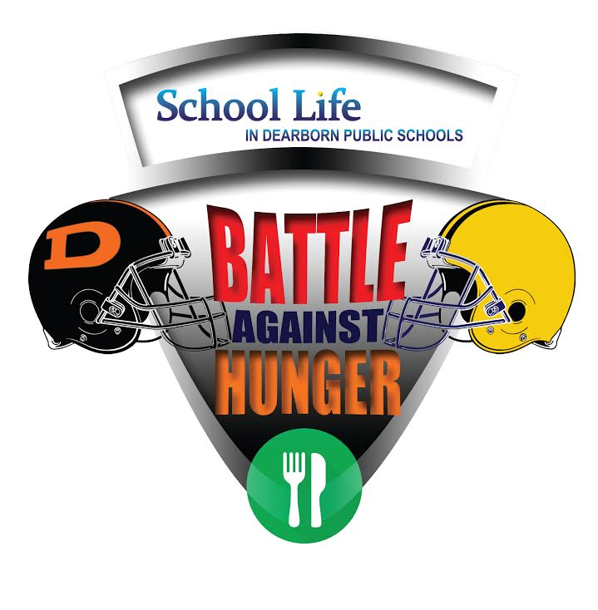](http://www.google.com/url?sa=i&rct=j&q=&esrc=s&source=images&cd=&ved=0ahUKEwjZ4rWAu9HPAhXEYyYKHa3SA10QjRwIBw&url=http://dhs.dearbornschools.org/tag/battle-against-hunger/&bvm=bv.135258522,d.eWE&psig=AFQjCNEuloLX6avJuDP0rMS3mDXC3PAKcA&ust=1476230951113417)

**Let’s help Fordson WIN this week off the field, while helping feed the hungry in our community! All this week you can bring in your cans or money donation to your classroom. Every $1 you donate will equal 4 cans of food! The classroom with the most donations will have a pizza party as a reward!**