Oakman Elementary
7545 Chase
Dearborn, MI 48126
(313) 827- 6500

OAKMAN LIONS ROLLER SKATING NIGHT

Who: 2nd -5th graders and Staff only are on the bus, first come first serve. K/1 are to be accompanied by parent and meet us there. No parents are to ride on the bus.
What: STAFF/PARENTS/STUDENTS Roller Skating Event
Where: Lincoln Park Skating Center : 1419 Southfield Rd, Lincoln Park 48146
When: Wednesday, Feb 15th. 4 to 6:30 pm
Cost: $10 ticket. Buy from Mrs. Dakroub or the PTA

Please sign the permission slip below and have your child return it by: FRIDAY 2-10-17 TO Mrs. Dakroub

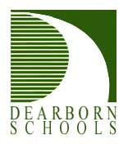
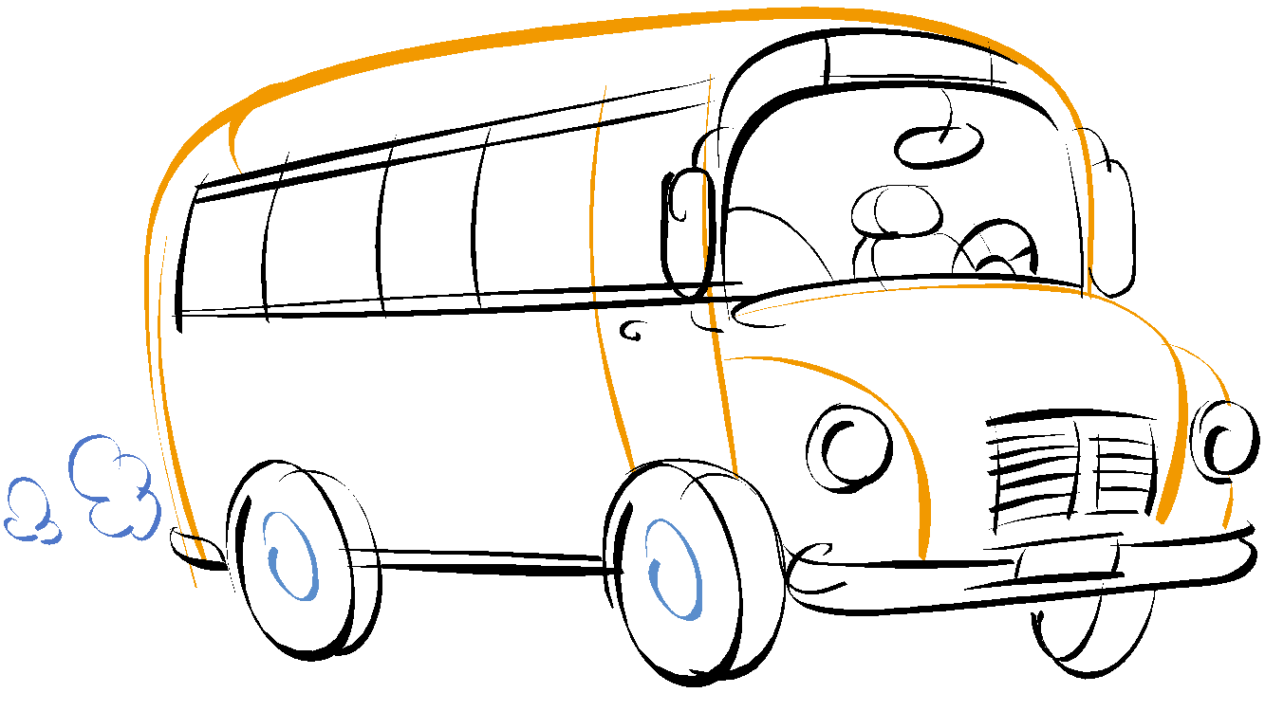
DEARBORN PUBLIC SCHOOLS
STUDENT PERMISSION SLIP

Parent permission to go on a field trip to: Lincoln Park Skating Center. I hereby give permission for my child or ward, to participate in field trip planned and directed by my child’s teacher and Oakman Staff. I understand that reasonable precautions will be taken to safeguard my child on field trips as is taken in all other school activities and I will not hold the Dearborn Board of Education or any of its employees responsible for any accident or loss which might be sustained. Attendance on the field trip is not part of the student’s grade for the course. Attendance is voluntary and no credit or “extra credit” is given. Such trips are for the purpose of enrichment as are any related activities, such as a field trip report.

Student Name: __________________________________________________________

Grade and Teacher: _________________________________

Parent Signature: _______________________Date:__02/___/2017
(Parent or Guardian)

********Parent Cell Phone: ______________________________

Local Physician’s Name: _________________________
Address: _______________________

*********Doctor Phone Number: ___________________________

