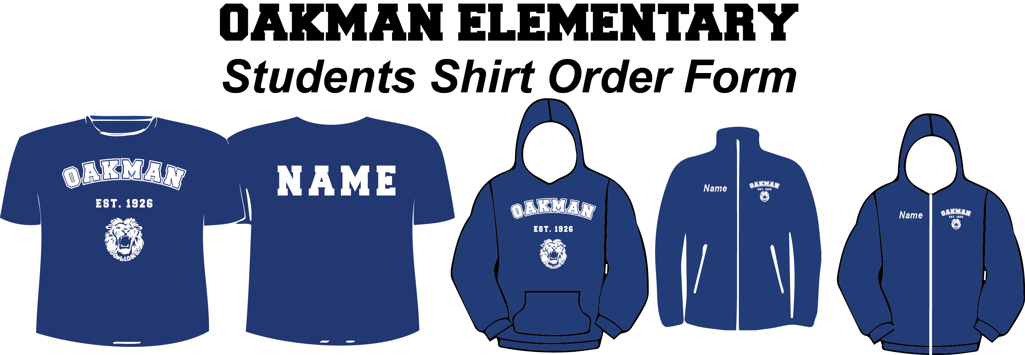

STUDENT NAME:____________________________________

Teacher Name:________________________________________

CELL PHONE: _______________________________________

METHOD OF PAYMENT: Cash only. No checks
Item | Quantity | Size | Color |  |  | Price | +$3.00 for Names | Total
Item | Quantity | Size | ROYAL |  |  | Price | +$3.00 for Names | Total
Short Sleeve T-Shirt |  |  |  |  |  | 10.00
Long Sleeve T-Shirt |  |  |  |  |  | 12.00
Short Sleeve T-Shirt  (Dry Fit) |  |  |  |  |  | 12.00
Long sleeve T-shirt (Dry Fit) |  |  |  |  |  | 15.00
Hooded Sweatshirt |  |  |  |  |  | 20.00
Zip Up Hooded * |  |  |  |  |  | 22.00
Fleece Jacket * |  |  |  |  |  | 22.00
Crewneck Sweatshirt |  |  |  |  |  | 16.00

*embroidery is stitched on the front

Sizes:
Youth Small _____ Youth Medium _____ Youth Large_____

Adult Small _____ Adult Medium _____ Adult Large _____ Adult XLarge _____

+$ 2.00 for: XXL, XXXL

ALL ORDERS ARE DUE TO CLASSROOM TEACHERS WITH CASH ONLY BY

MARCH 10th CASH ONLY!

